

Foundations of Programming
Assignment No. : 13

PROBLEM STATEMENT:
Write a program in C to accept a number from the user and print the digits of the number in reverse order.

OBJECTIVE:
• To understand number manipulation using loops
. • To learn the use of modulo (%) and division (/) operators.
• To implement logic for reversing digits of a number.
• To improve problem-solving skills using iterative structures.

THEORY:
• To understand number manipulation using loops.
• To learn the use of modulo (%) and division (/) operators
. • To implement logic for reversing digits of a number
. • To improve problem-solving skills using iterative structures.

PLATFORM:
Linux

ALGORITHM:
Start.
Declare an integer variable num to store the user input and remainder to store each digit.
Input the number from the user.
Loop while num is not equal to zero:
- Find the last digit using the modulo operator: remainder = num % 10.
- Print the remainder.
- Remove the last digit from the number using integer division: num = num / 10.
End.

FLOWCHART:

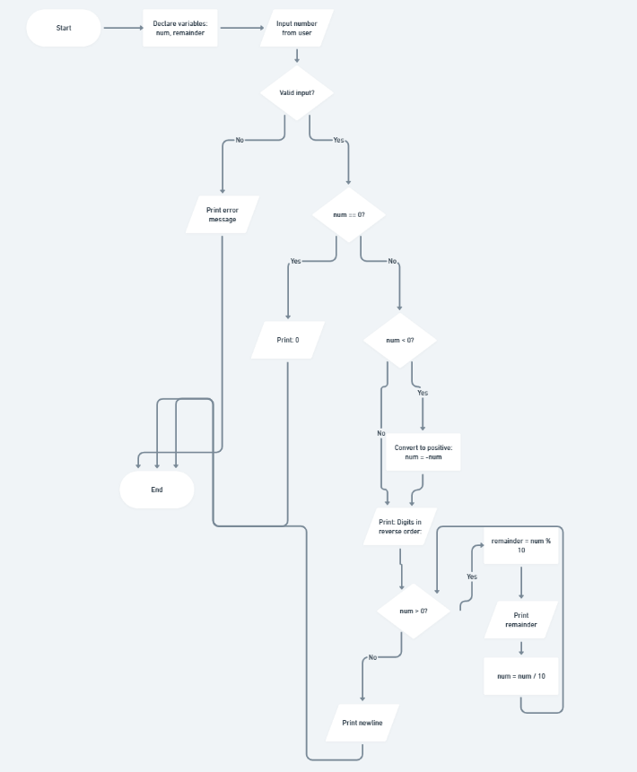

C PROGRAM:
#include <stdio.h>

int main() {
int num, remainder;

// Input from user
printf("Enter an integer number: ");
if (scanf("%d", &num) != 1) {
printf("Invalid input. Please enter an integer.\n");
return 1;
}

// Handle the case if the number is 0
if (num == 0) {
printf("Digits in reverse order: 0\n");
return 0;
}

// Handle negative numbers by converting to positive
if (num < 0) {
num = -num;
}

printf("Digits in reverse order: ");

// Logic to reverse digits
while (num > 0) {
remainder = num % 10; // Extract the last digit
printf("%d ", remainder); // Print the digit
num = num / 10; // Remove the last digit
}

printf("\n");

return 0;
}

INPUT/OUTPUT:
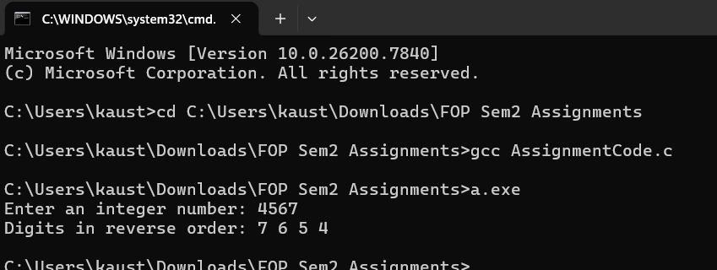

CONCLUSION:
Thus, the program to print the digits of a number in reverse order was successfully implemented using C programming. The program demonstrates the effective use of loops, modulo operator, and division operator.

FAQs:
- Why is the modulo operator (%) used in this program?
- Why is division by 10 used after extracting each digit?
- What happens if the input number is zero?
- How will the program behave for negative numbers?
- Why is a while loop preferred for this operation?

